Chip back potential is the level which bulk silicon is maintained by on-chip connection, or it is the level to which the chip back must be connected when specifically stated below. If no potential is given the chip back should be isolated.

.028”

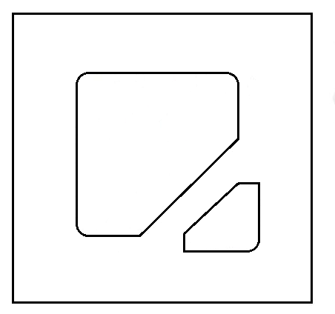
C
A
.015”
.015”
.007”

.028”

BACKSIDE IS CATHODE AND IS COMMON TO TOP CATHODE PAD

Top Material: Al
Backside Material: Au
Bond Pad Size: .007” min.
Backside: CATHODE
Mask Ref:

APPROVED BY: DK DIE SIZE .028” X .028” DATE: 8/31/21
MFG: CDI THICKNESS .009” P/N: 1N829A
DG 10.1.2

Rev B, 7/19/02

